Findings
- Region
Table : PMS_RPT_REGION
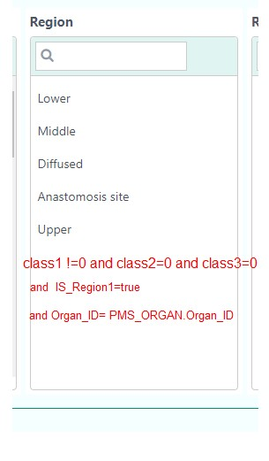
- Findings:
Table: PMS_RPT_DIAGONOSIS
"CLASS1" != 0 and "CLASS2"=0 and "CLASS3"=0 and "ORGAN_ID"=PMS_ORGAN.ORGAN_ID

- Region 2:
Table: PMS_RPT_REGION
"CLASS1" = PMS_ORGAN.ORGAN_ID and "CLASS2"=PMS_ORGAN.ORGAN_ID and

"CLASS3"=PMS_ORGAN.ORGAN_ID and "ORGAN_ID"= PMS_ORGAN.ORGAN_ID
- Number:
Table: PMS_RPT_DIAGONOSIS

"CLASS1"=”PMS_RPT_DIAGONOSIS”.CLASS1 and "CLASS2"=0 and "CLASS3" !=0 and "ORGAN_ID"=PMS_ORGAN.ORGAN_ID

- Size:
Table: PMS_RPT_DIAGONOSIS
"CLASS1" = ”PMS_RPT_DIAGONOSIS”.CLASS1 and "CLASS2" != 0 and "CLASS3"=0 and "ORGAN_ID"=PMS_ORGAN.ORGAN_ID
Findings DTL

Table : "PMS_RPT_FINDINGS"

All Header and child record:

"PMS_RPT_FINDINGS"."DIAGONOSIS_CLASS1_CODE"=”PMS_RPT_DIAGONOSIS”.CLASS1

=====> Get “CLASS1” as A

A= CLASS1 (Here A == "PMS_RPT_FINDINGS".CLASS1 )

Header / Title :

"DIAGONOSIS_CLASS1_CODE"=”PMS_RPT_DIAGONOSIS”.CLASS1 and "PMS_RPT_FINDINGS"."CLASS1"= A and "CLASS2"=0 and "CLASS3"=0;

Child:

"DIAGONOSIS_CLASS1_CODE"=”PMS_RPT_DIAGONOSIS”.CLASS1 and "PMS_RPT_FINDINGS"."CLASS1"= A and "CLASS2" != 0 and "CLASS3"=0;

IS_INPUT: If IS_INPUT== true, then it will take user input.

Example:

SELECT * FROM "PMS_RPT_FINDINGS" where "DIAGONOSIS_CLASS1_CODE"=10001015;

SELECT * FROM "PMS_RPT_FINDINGS" where "DIAGONOSIS_CLASS1_CODE"=10001015 and "CLASS1"=100010151 and "CLASS2"=0 and "CLASS3"=0; //Header

SELECT * FROM "PMS_RPT_FINDINGS" where "DIAGONOSIS_CLASS1_CODE"=10001015 and "CLASS1"=100010151 and "CLASS2"<>0 and "CLASS3"=0;

Intervention

Table: PMS_RPT_TREATMENT

All Record:

"DIAGONOSIS_ID"="PMS_RPT_DIAGONOSIS".DIAGONOSIS_ID

Group by "GROUPED_ID"

Header :

PMS_RPT_TREATMENT. "GROUPED_ID"= GROUPED_ID and CLASS1=0 and CLASS2= 0 and CLASS3=0

SUB- Header:

PMS_RPT_TREATMENT. "GROUPED_ID"= GROUPED_ID and CLASS1 != 0 and CLASS2= 0 and CLASS3=0

Child:

PMS_RPT_TREATMENT. "GROUPED_ID"= GROUPED_ID and CLASS1 = SUB-Header.Class1 and CLASS2 !=0 and CLASS3=0

\
